**ASE MID TERM – 1 REPORT**

**PAVANI SREE LAKSHMI PENUMATHSA**

**16149283**

**Mobile Web APP – MapMyRoute**

**Description:**

MapMyRoute Mobile Web App helps users in planning their route during their travel. Main purpose of this App is to help people finding the best route. This is very useful for people who have either newly moved to a city or travelling to a new place. This is also helpful for the tourists in selecting the easy route and deciding on the places to visit during their tour.

With this App you can,

1. Create a route, add description and pictures to the places they have visited and store the route.

2. Browse through the list of routes saved and select the best route and the places to visit during the trip.

3. Share their experience and images during the trip to their friends and family anytime during their travel on social networks.

4. Rate the routes based on their experience.

**Design:**

Please kindly see the last page of this report.

**Features Implemented:**

Used the below existing API’s,

**Facebook API:** To share descriptions and pictures from MapMyRoute App with friends and family members.

https://developers.facebook.com/

**Google Maps API:** To get the current location, and display the places of interest with in 500 ft radius.

<https://maps.googleapis.com/maps/api/js?key=API_KEY&sensor=SET_TO_TRUE_OR_FALSE>

Database:

Created SQL Server Database using visual studio 2012 as part of the ASP .net MVC Application for this project.

**Mobile user Interface:**

Developed my own Mobile UI (included JQuery UI libraries wherever required).

**ScreenShots (chrome):**

**Login Page:**

Registered users will able to login using this page. Once the user enters his credentials, verification is done against the existing records and will be navigated to Home Page, if user exists.

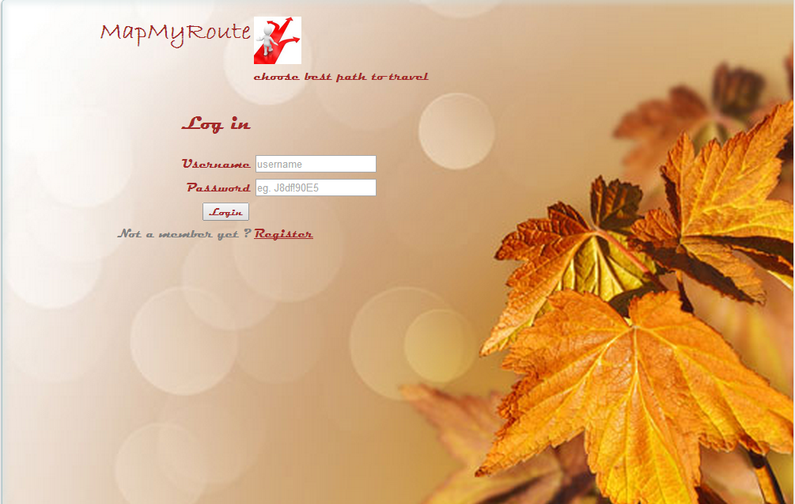

**Sign Up page:**

First time Users will able to register using this page. The entered details are saved.

Few validations like password and confirm password should match etc are also implemented.

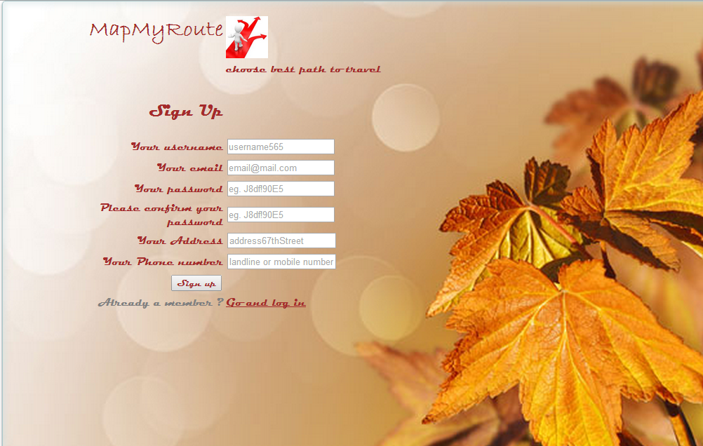

Home Page:

Once the user successfully logs in, he will be navigated to the Home page.

The user will be able to Create Route or see the existing routes here.

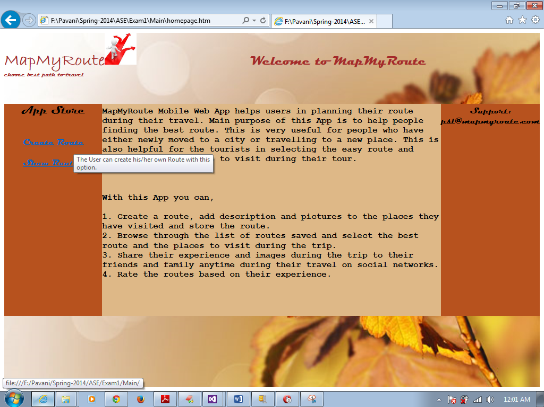

Hover messages in the Home page.

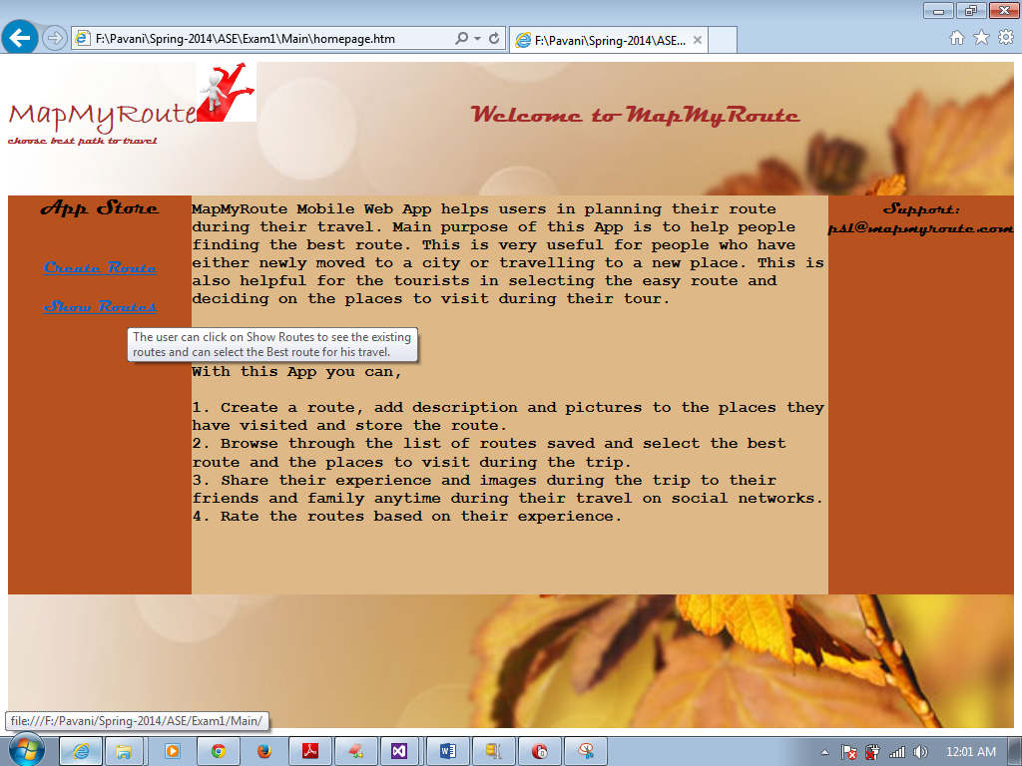

**Screen shots (Opera emulator):**

**Log in page:**

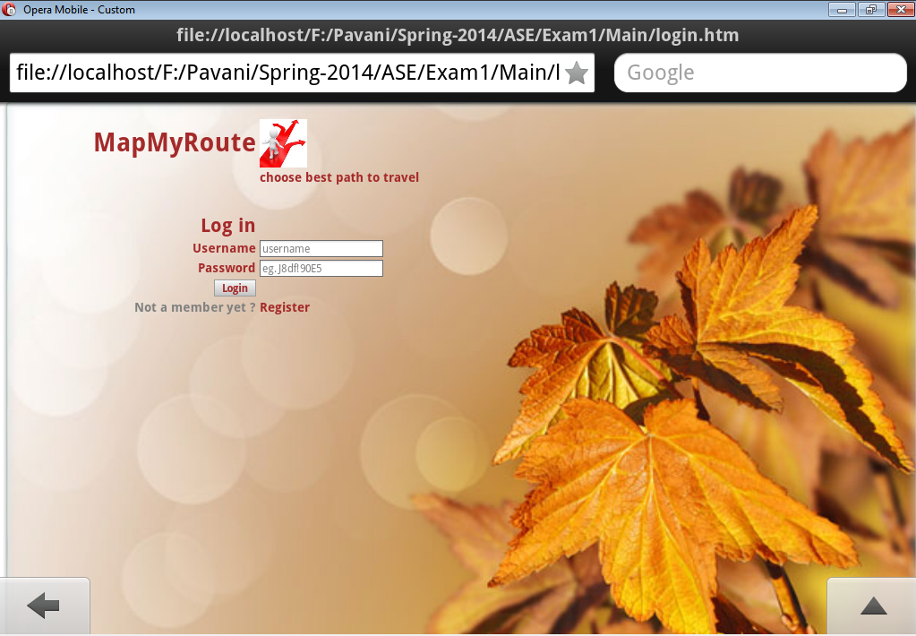

**Signup page:**

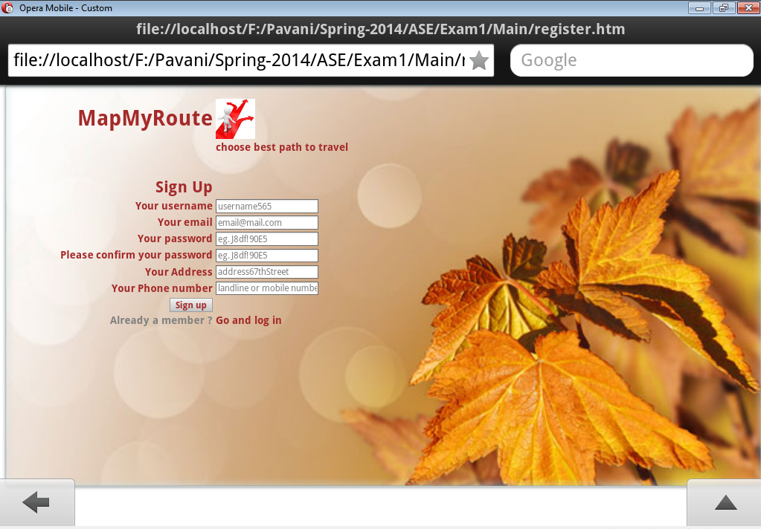

**Home page:**

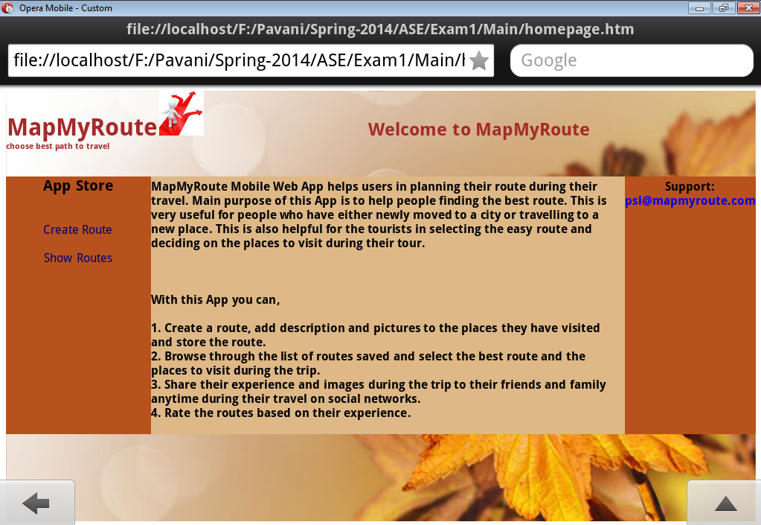

Once the user clicks on the App Store in the Home page, he will be taken to the below page for creating and seeing the routes.

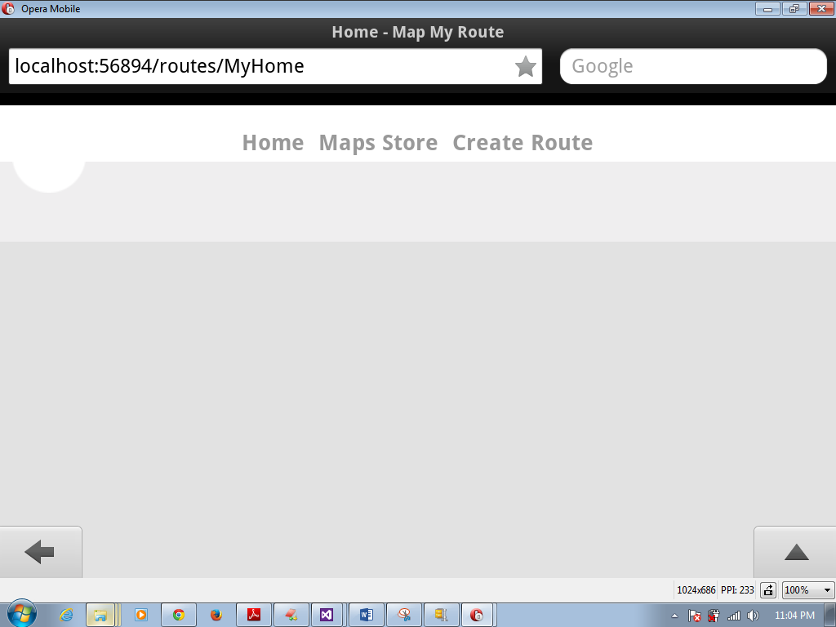

**Create Route page:**

Once the user clicks on the Create Route button he will be taken to the below page. The users current location is indicated with the blue icon and the rest are places of interest near by (500 mts radius) to the user’s current location.

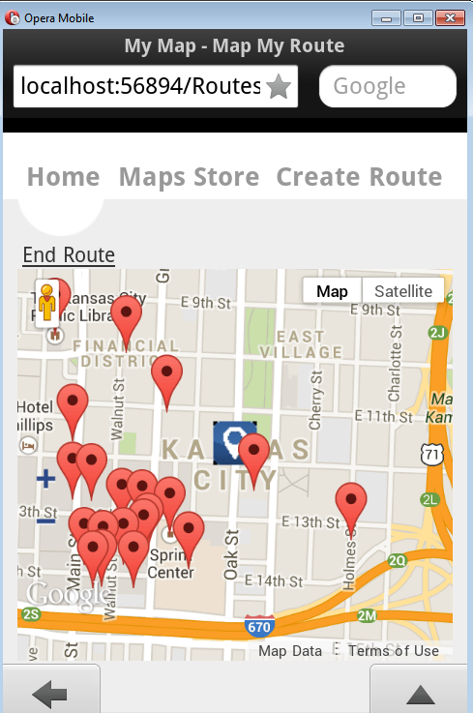

The user can click on any of these pop ups to check in at that place.

Once he clicks on the pop up, we can see the pop up with the place name and the check in button for checking in at that place. The user can check in any number of places he wishes to.

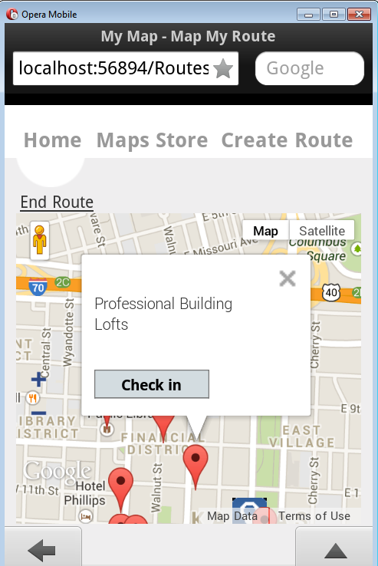

The user can click on End Route button once finishes his trip. The checked in places are stored in the HTML local storage until the user clicks on the End Route button.

Once the user clicks on the End Route button, he will be taken to the below screen, to add the description of the places and upload pictures.

He can also share his experiences on facebook by clicking on the share button in this page.

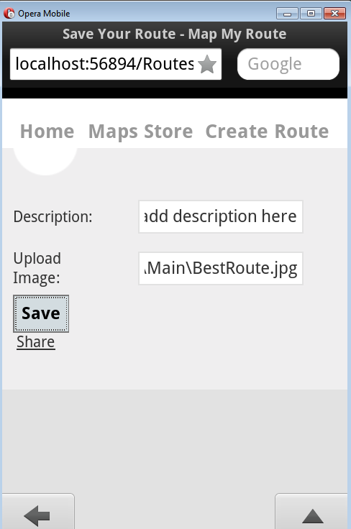

Once the user enters the description, this data is stored in the SQL Server for further viewing.

Share button takes the user to the below screen, where he can post his experience to the facebook.

eb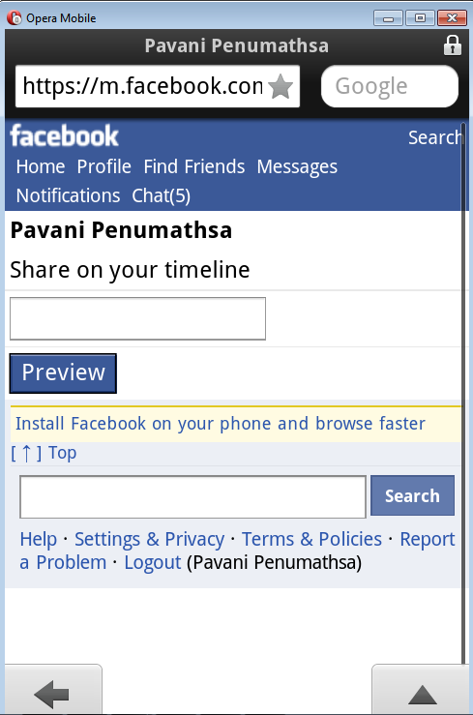

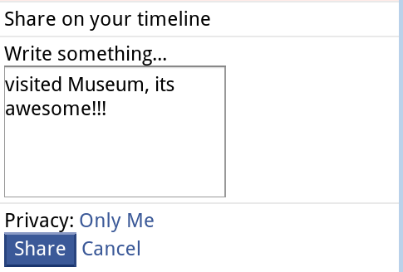

Clicking on the share button will post his comments to the facebook.

**Maps Store page:**

The users can click on the Show Routes button to see the existing routes.

The list of the existing routes are displayed as shown in the below screen.

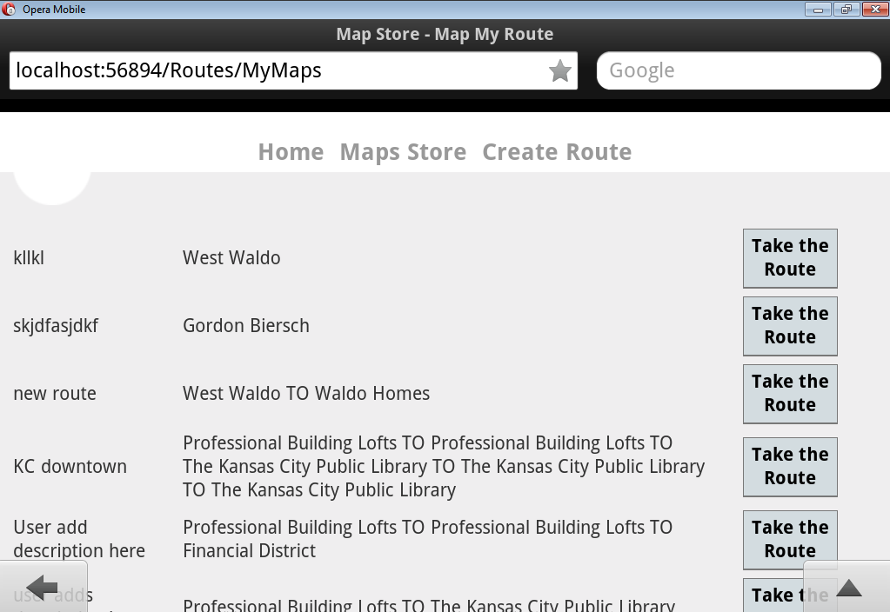

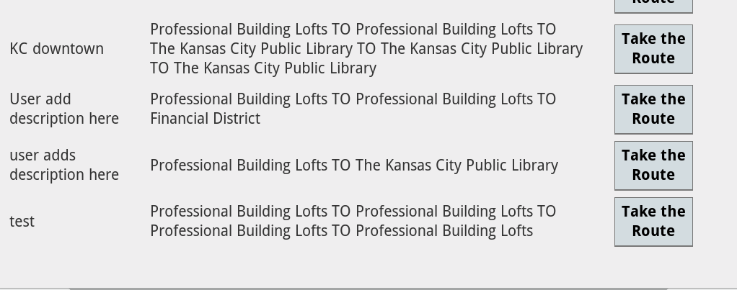

The user can choose on any of these routes by clicking the Take the Route button next to that particular route, which will take him to the below screen

Users current location is displayed with blue icon. The places checked in for the selected route are displayed in the below map which are indicated by the black icon and the order is also displayed on the icon.

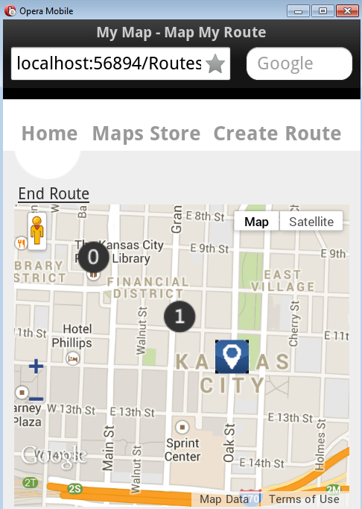

The user can see the place’s description here.

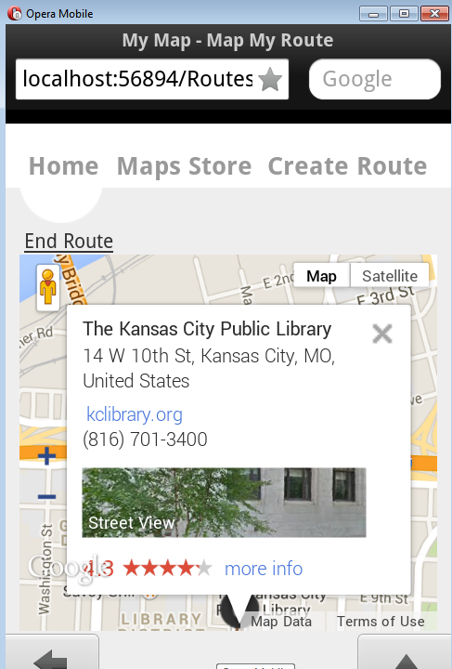

The user can click on the place’s icon he wishes to check in.

Once he reached a particular place on the route he is prompted for checkin and see the next location details.

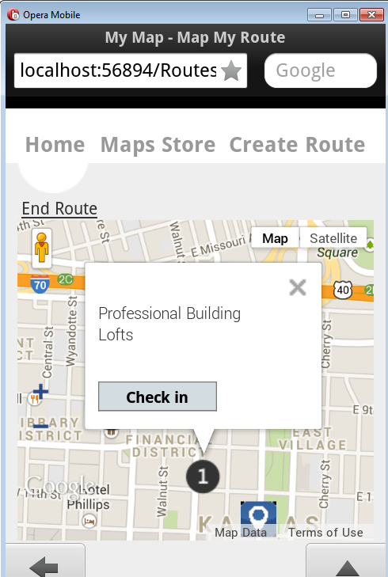

**GitHub URL:**

**https://github.com/PavaniPenumathsa/ASE-Midterm1-Submission**

**Limitations:**

App User Interface can be improved further.

Introducing option to ‘Like’ with the Like button for the routes would be good.

**References:**

Google developers site.

Facebook developers site.

For image uploading and saving:  
<http://thiscouldbebetter.wordpress.com/2012/12/20/uploading-and-displaying-an-image-from-a-file-using-html5-and-javascript/>  
  
ASE Tutorials provided.

**Source code details: Listed important files.**

**I have created ASP .NET MVC application using Visual Studio 2012. Used Opera emulator for screen shots and testing MapMyRoute App.**

**HTML Code:**

**Homepage:** MapMyRoute Homepage code.

**Login:** Login code.

**Register:** Sign up code.

**MyRoute:** Current location, nearby locations, check in and End Route.

**MyMap:** Browsing through list of existing routes.

**_RouteLayout:** Layout details.

**Javascript:**

**Validation.js:** Validation in the Login and Sign up pages are implemented.

**googleMap.js:** Storing and retrieving HTML local storage data. Calling controller to insert data for Create Route and fetching data from database for displaying the existing routes information. Sharing experience on Facebook.

**Controller:**

**RoutesController.cs:** Inserting data into database and fetching data from database as per the request from JavaScript code.

**SQL Server Database:** MapMyRouteData, **Table name:** MyMaps (screen shot provided below).

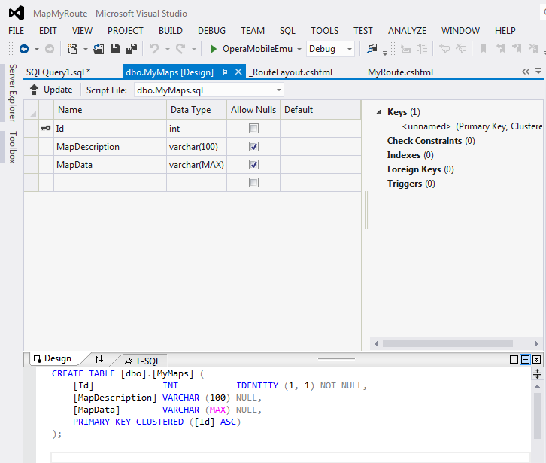

**Design:**

( NOTE: I have realized that I have to submit class diagram and architecture diagram at the last moment of the report submission, hence I’m submitted the images of my hand written diagrams. Please kindly accept. In future I will be more careful about these things. Thank you.)

**Architecture Diagram:**

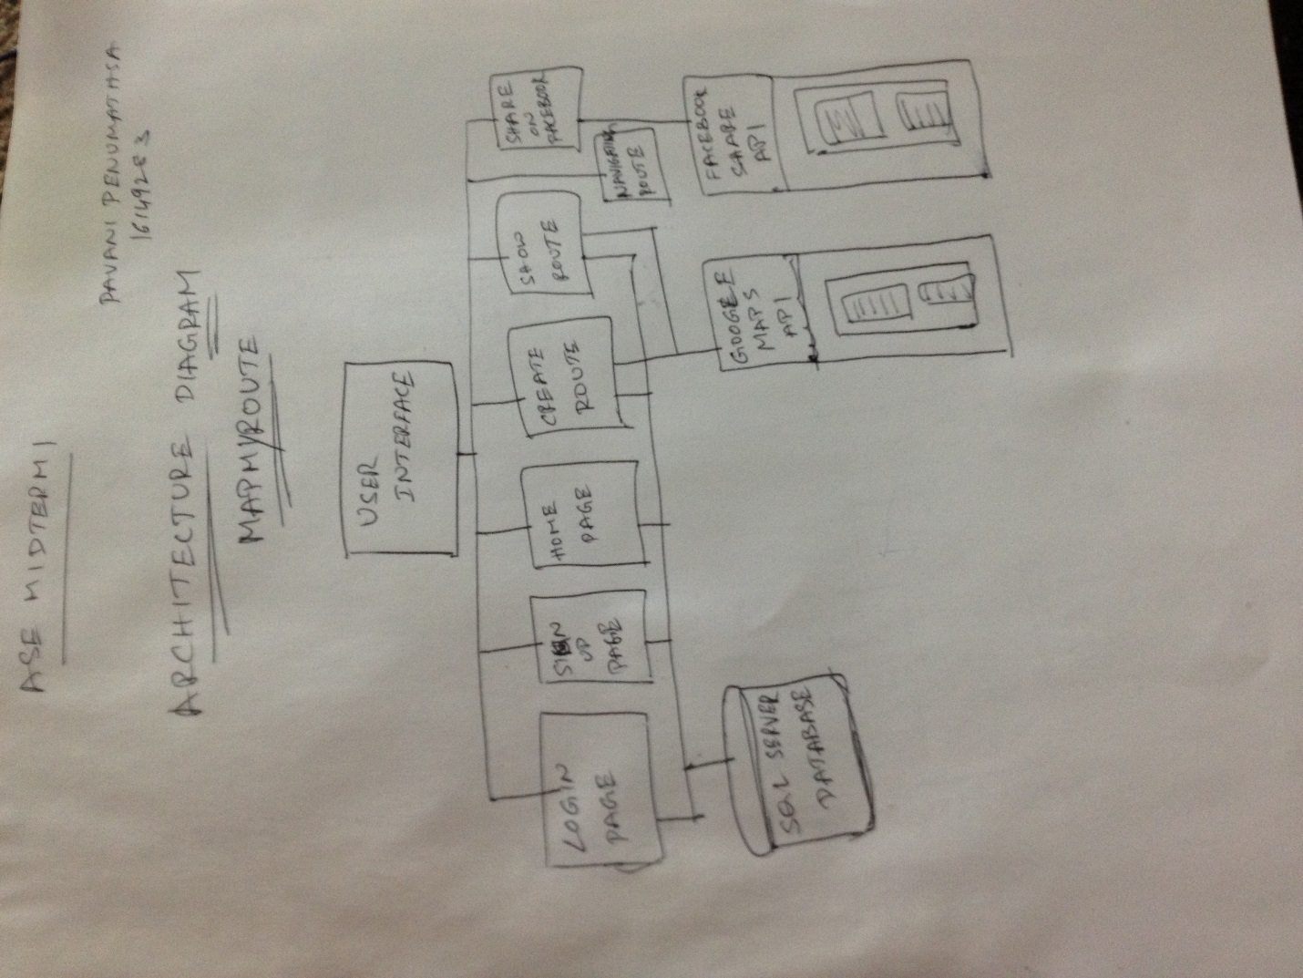

**Class Diagram:**

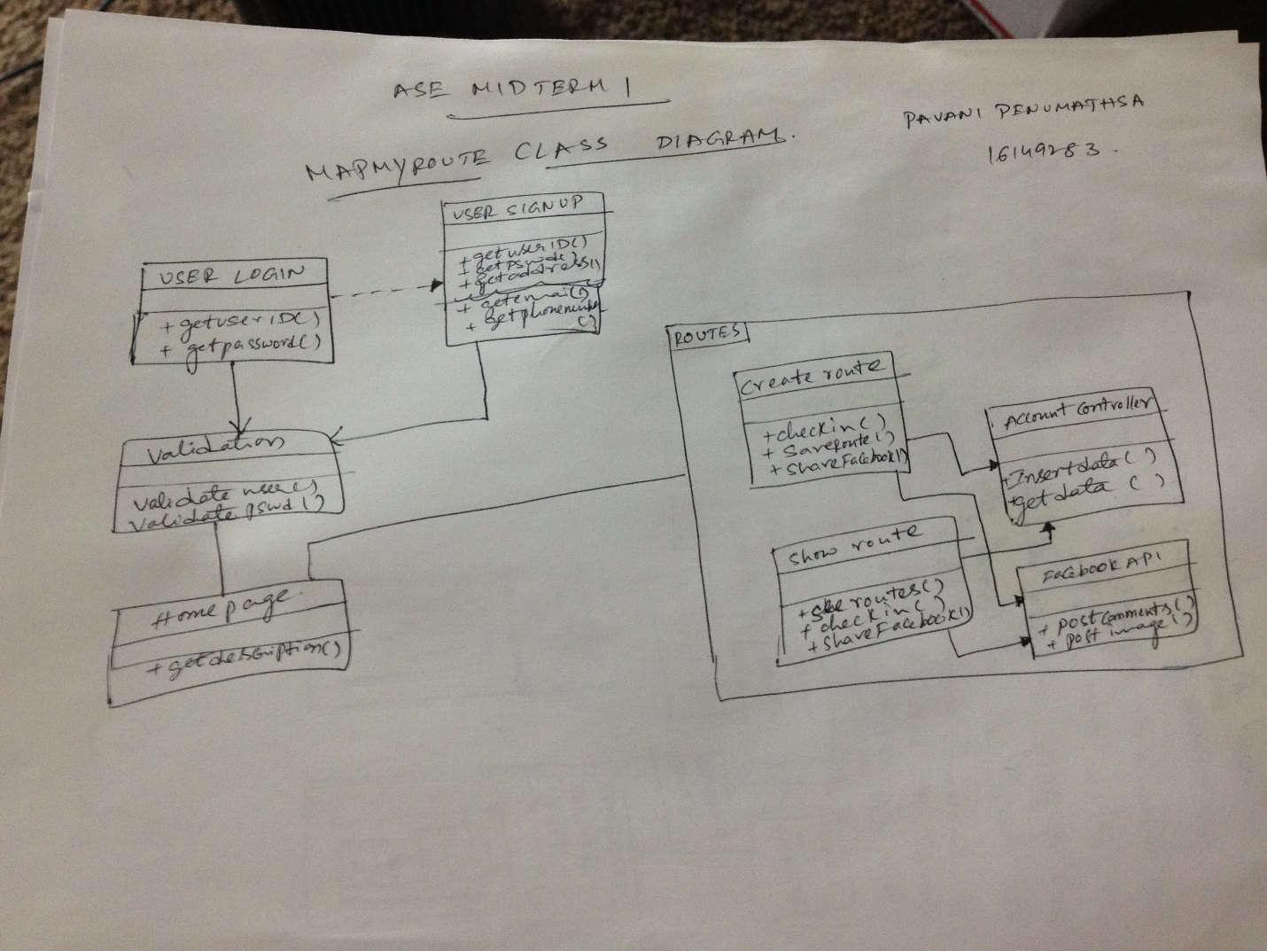

**END OF THE REPORT**